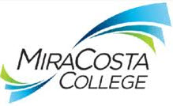
Federal Work Study (FWS)

Federal Work Study offers part-time, on-campus jobs to eligible financial aid applicants.

Getting Started:

- Complete a FAFSA at https://studentaid.gov/h/apply-for-aid/fafsa for the current school year.
- If you are eligible for Federal Work Study (FWS), a FWS checklist will appear on your SURF Tasks List.
If you have a “Federal Work Study” checklist item on your tasks:

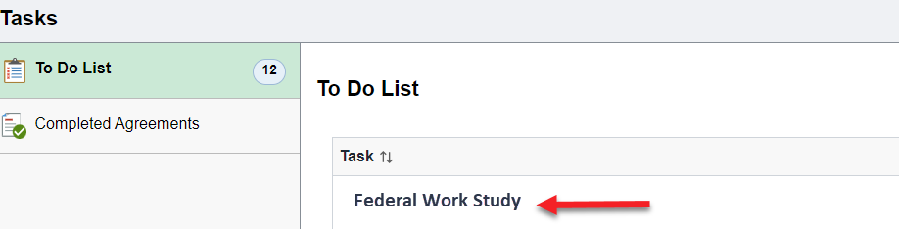

- You are approved to work on campus and may begin the job search process on JAIN.
- Before you can qualify for a FWS position you must be enrolled in at least 6.0 units each semester and meet Satisfactory Academic Progress (SAP) requirements.
- You may begin the job search process with the Career Center at this time but cannot begin working in a FWS position until you have completed the onboarding process.

If you do not see FWS listed as a checklist, you may contact the Financial Aid Office with questions regarding your eligibility at 760-795-6711 or email at MCCFinAid@miracosta.edu

Searching for a Job:
Create your JAIN profile by logging in at www.miracosta.edu/JAIN using your SURF ID and password.
- If you do not have a resume, click HERE in order to access the Career Center resume and cover letter template.
- Upload your resume onto JAIN, by going to My Profile and then Resumes
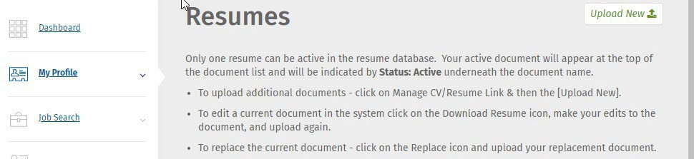

- Search and apply to on-campus FWS positions on JAIN
(Job Search > Job Search > Position Type > Job Paid Through Work Study)

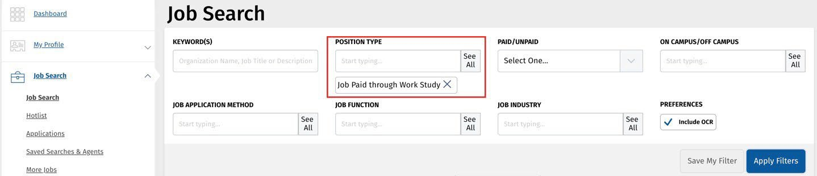

If you are offered the position, Congratulations! You are ready to begin the onboarding process.

- To begin the onboarding process, your supervisor will initiate the hiring process by submitting a request to hire on Workday.
- Report your job on JAIN under your Dashboard Options: Report Employment
- If you have not worked on campus in the last year, you may need to complete the entire onboarding process. Please check with the Student Employment Coordinator.
If you have any questions or need assistance searching for a job may contact the Career Center at 760-795-6772 or email at careers@miracosta.edu.

